**TITLE**

Lab- 7: Embed developed Machine Learning Models to Web page.

**Content**

|  |  |  |
| --- | --- | --- |
| **S.NO** | **Topic** | **Page Number** |
| 1 | Embed developed Machine Learning Models to Web page. | 3 - 7 |

**Lab -7**

**AIM:**

Embed developed Machine Learning Models to Web page.

**Description:**

From the previous experiments we learn how to make an ml prediction model. Now, we will integrate our model to web page so that it can be used by user how knows only to interact with web page and not code.

In this we are using salary predictor based on the years of experience. When you type you expected experience year it will down show the expected salary a person of this much year of experience should get.

**Code and Output:**

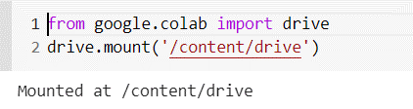

Fig 1: Connection with google drive

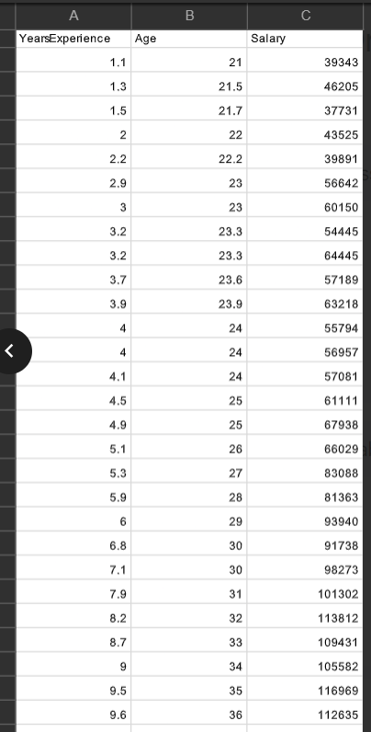

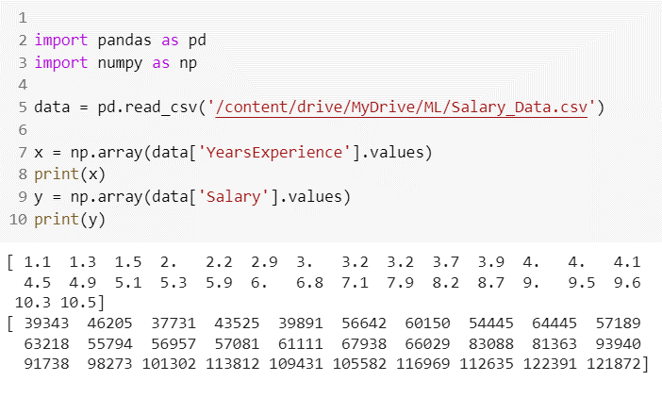

Fig 2: Importing Data

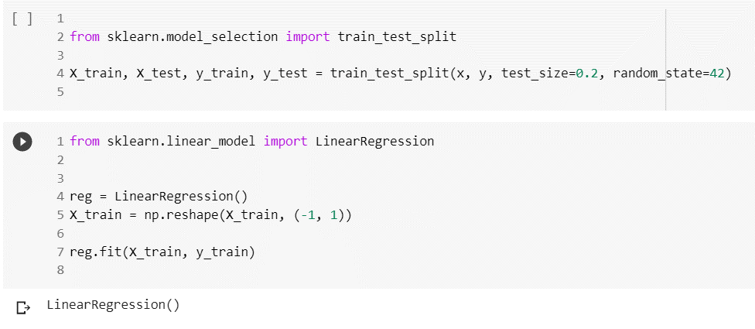

Fig 3: Importing sklearn and performing linear regression

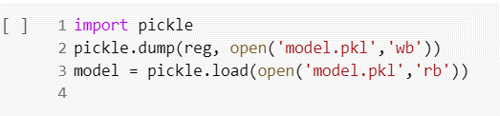

Fig 4: Creating model

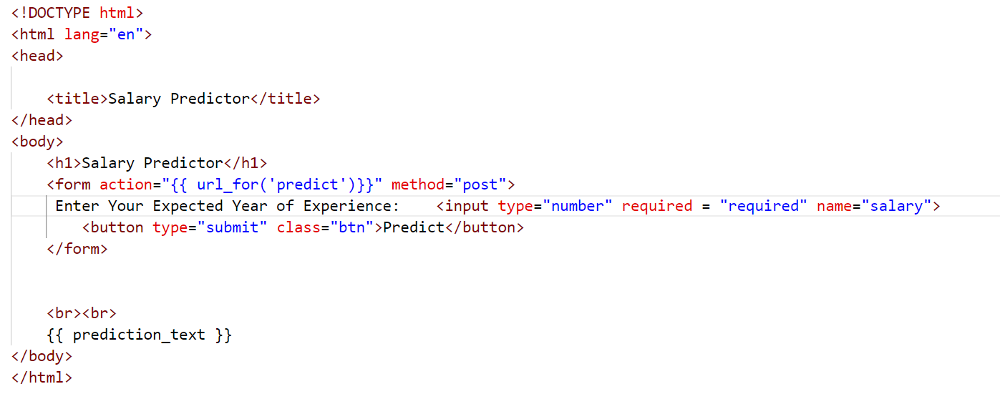

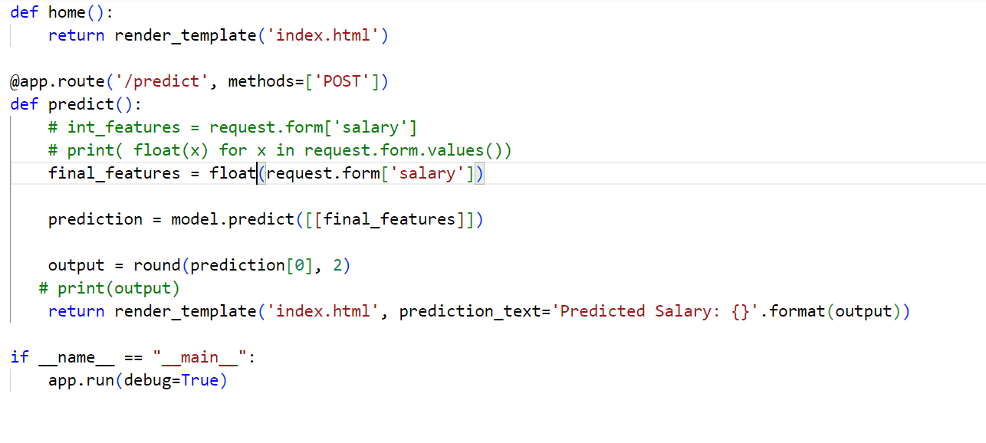

Fig 5: HTML and Flask code for integration

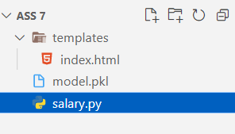

Fig 6: File Structure

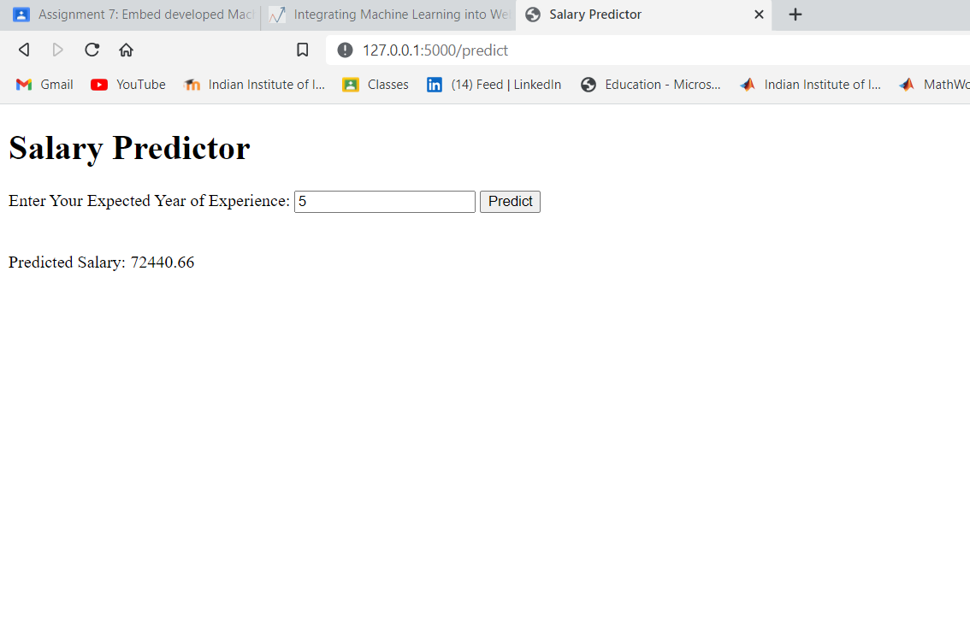

Fig 7: Output at localhost:5000

**Conclusion:**

The above model Predicts the salary of the user based on the year of experience however the prediction can be more precise if we train this on a large dataset.